Contents

I. Introduction 1

II. Analytic Phase 1

III. Realization Phase 6

IV. User Guide 7

V. Conclusion 11

1. Introduction

This report outlines the current state of projector management at AICS Cameroon and proposes a plan for improvement. Projectors are vital tools for enhancing classroom presentations and student engagement. However, improper management can lead to inefficiencies, equipment damage, and disruption of learning activities.

1. ****Analytic Phase****
2. **Use Case Diagram:**

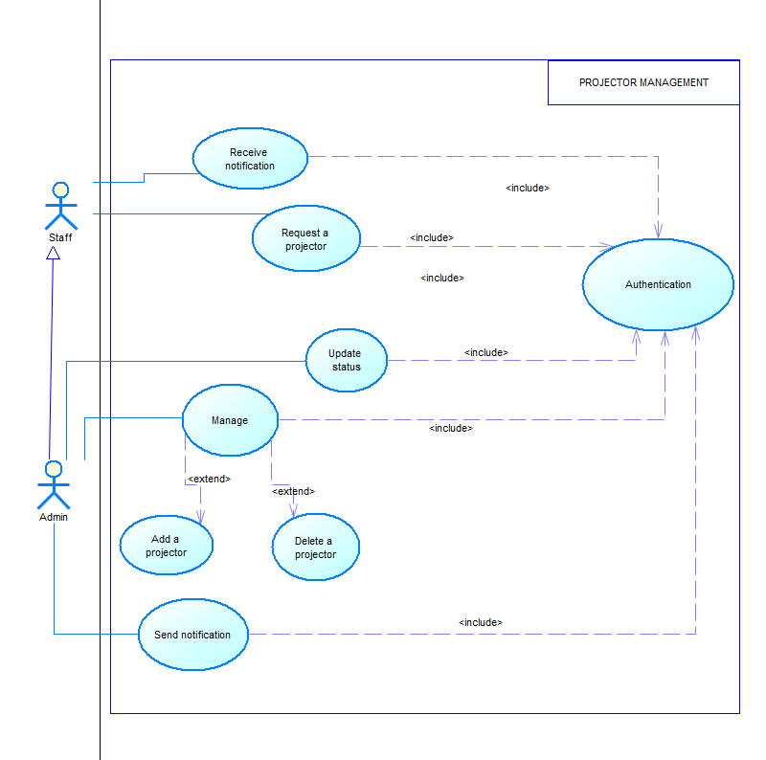

1. **Class Diagram :**

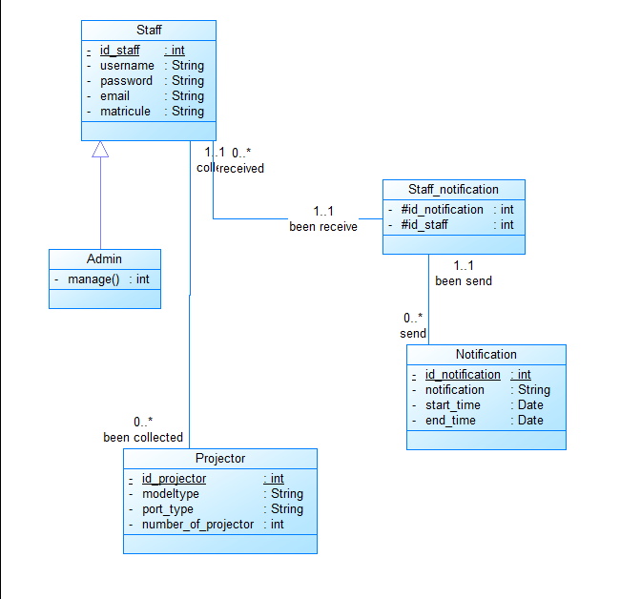

1. **Activity Diagram :**

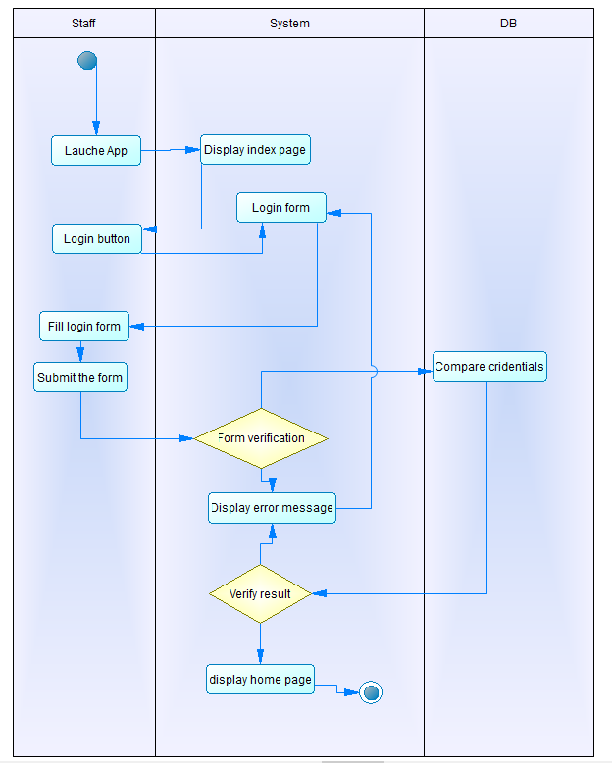

1. **Sequence Diagram:**

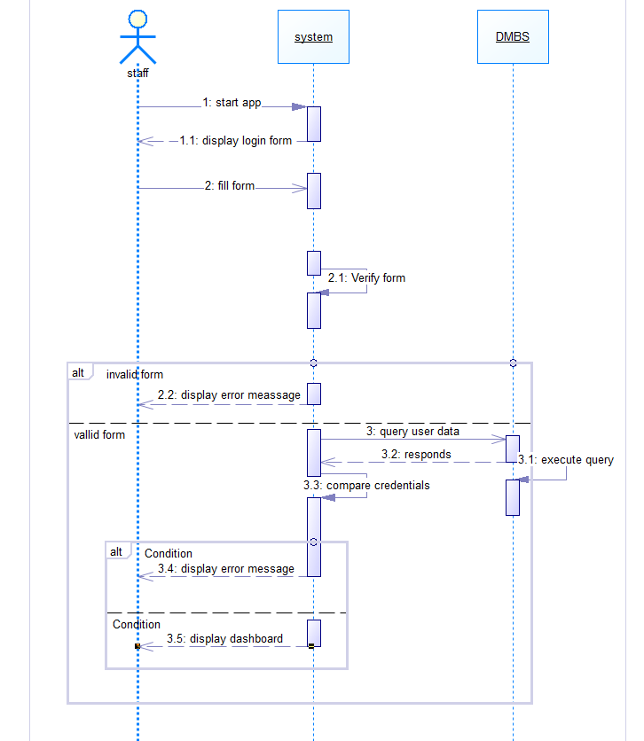

**Request projector sequence diagram**

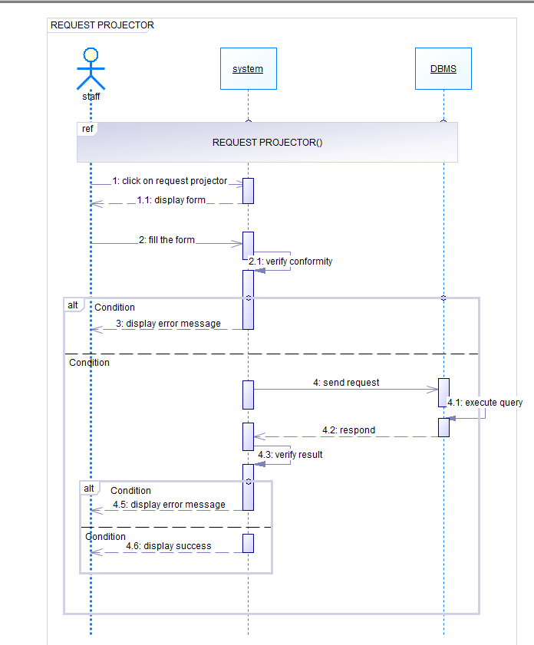

1. Realization Phase

**Technology Stack:**

* **Backend:** Django (Python web framework)
* **Frontend:** HTML, CSS (for user interface)
* **Database:** MySQL (

**Application Features:**

* **Admin Panel :**
  + Manage projector inventory (add, edit, delete).
  + View projector usage reports (reservations, maintenance history).
  + Create and manage user accounts (assign roles).
* **User Interface :**
  + Search for available projectors based on date and location.
  + Reserve projectors for specific time slots.
  + View and manage existing reservations.
  + Cancel reservations.

IV. User Guide

* + 1. **Accessing the application:**

The application lands with a beautiful home page where each user will be asked to login or register and be directed to its different page to perform his/her activities.

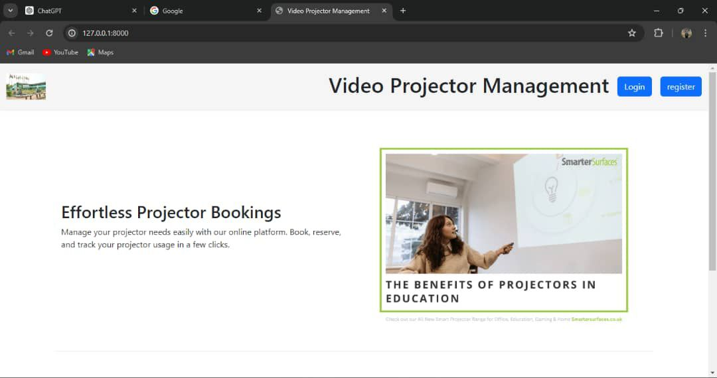

*Home page*

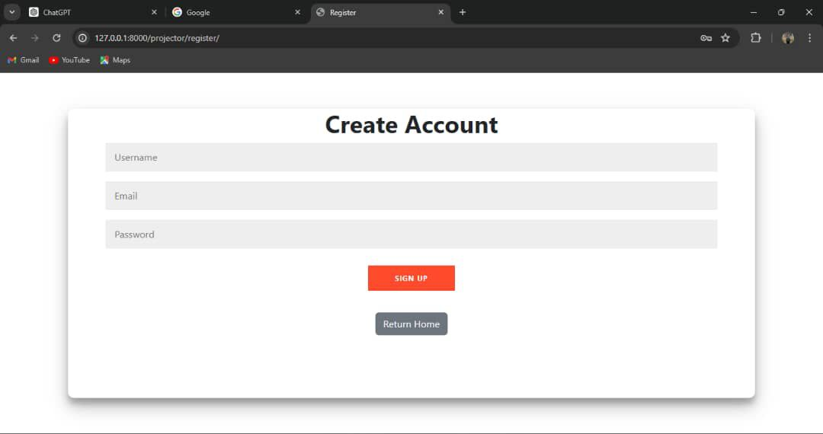

*Register page*

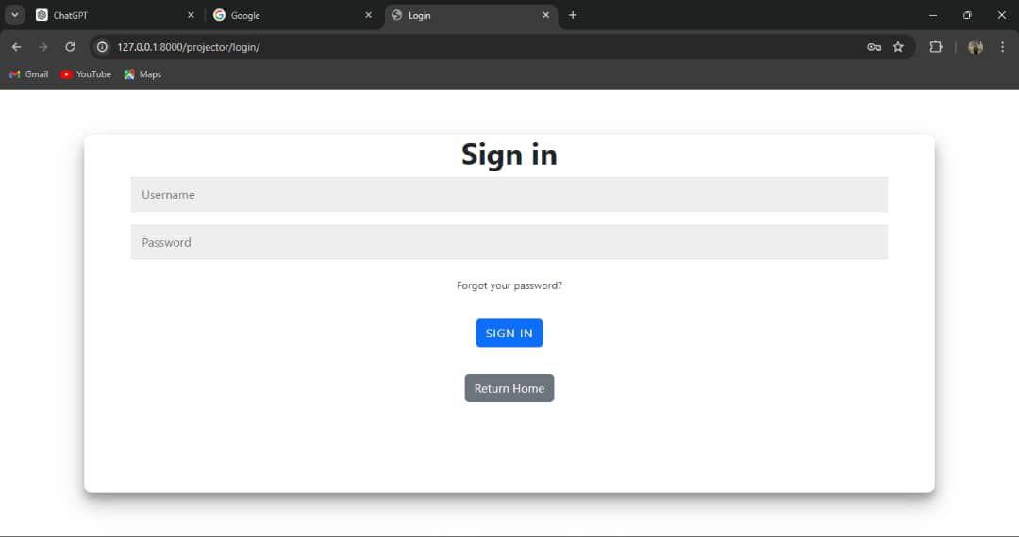

*Login page*

* + 1. **The admin dashboard**

Here the user has information from the database and their state and with a left menu to navigate through the main pages of the app. He can add users, projectors and control the withdrawal of each projector. He can also manage (users and projectors) and delete (users and\or projectors)

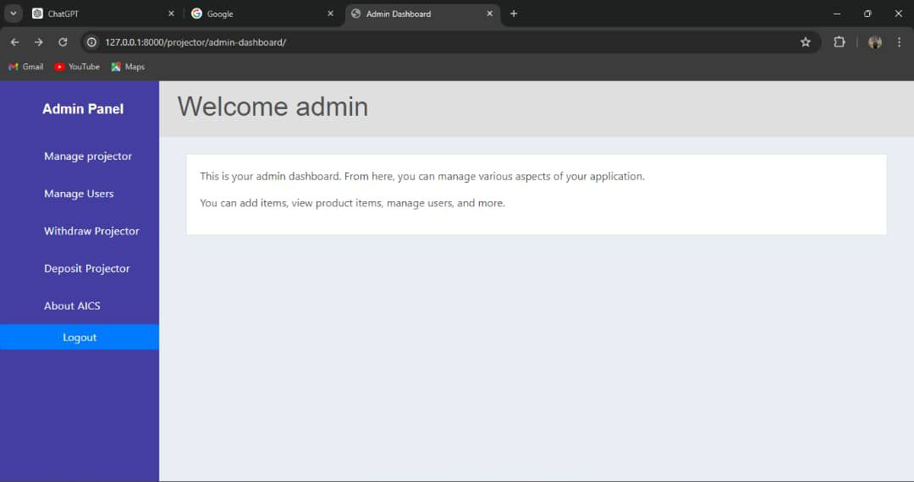

*Admin page*

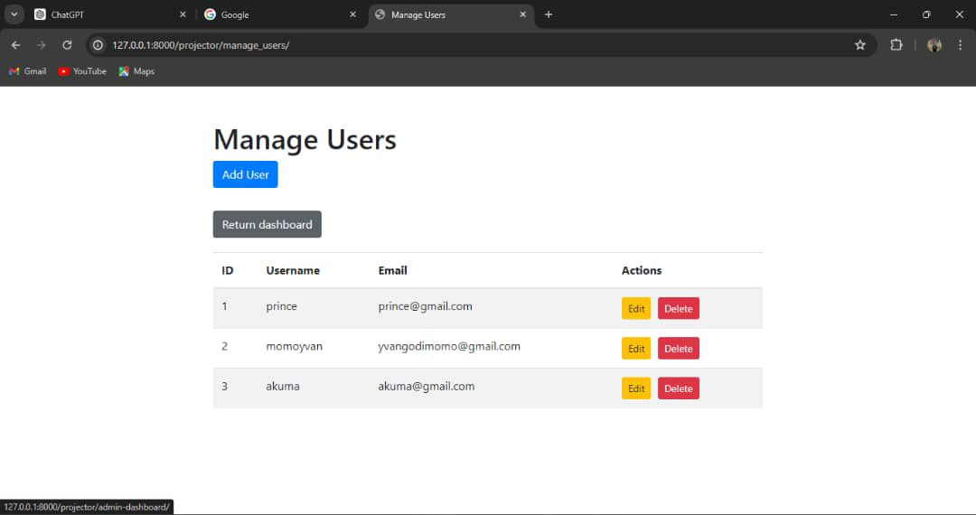

*Manage user’s page*

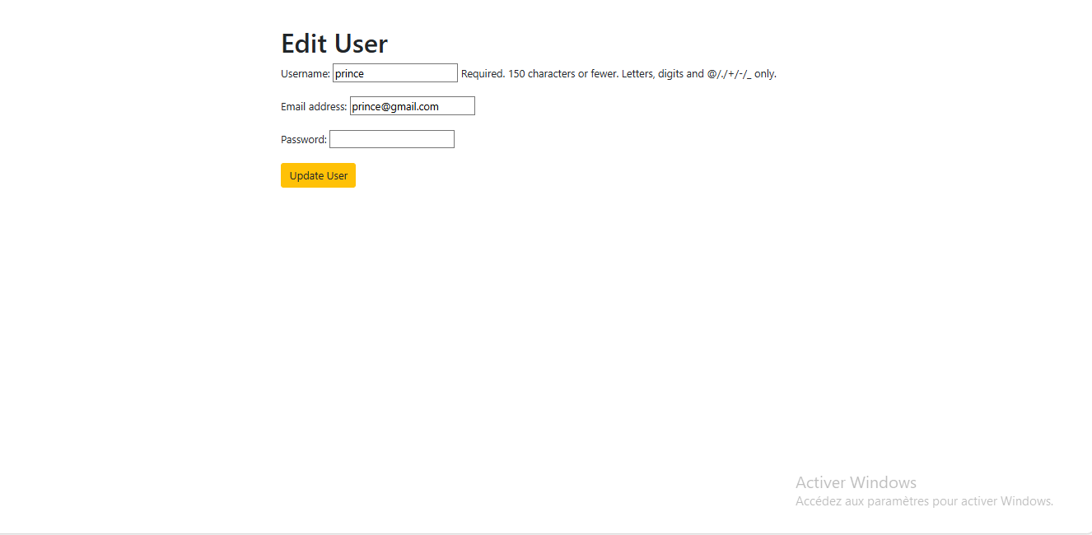

Edit user

* + 1. Booking for a projector

The have an interactive and easy to use interface to ease the users/teachers to book for a projector and all the accessories that goes with the projector. Then the user can also see the booking history and the projectors available.

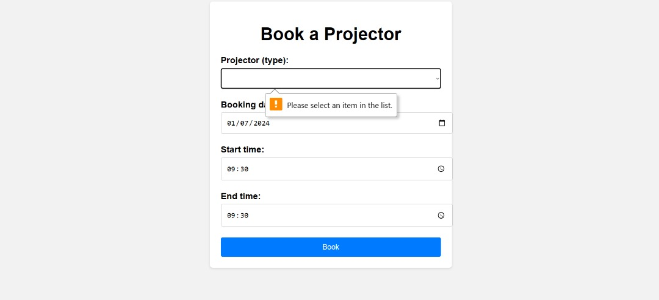

*Booking projector page*

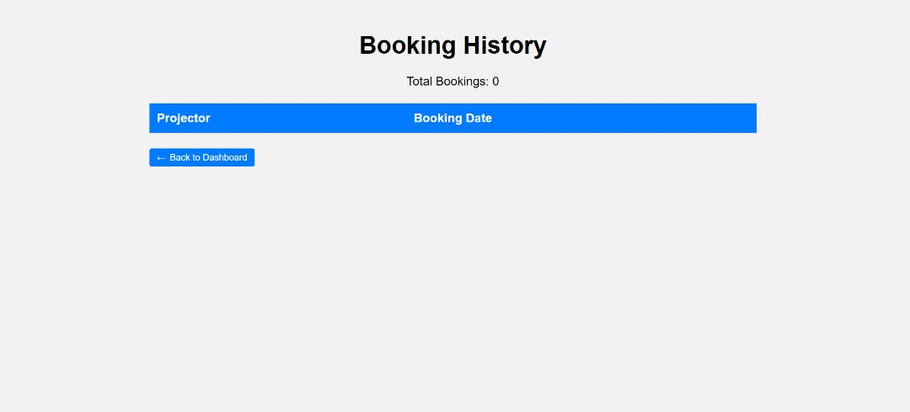

Booking History

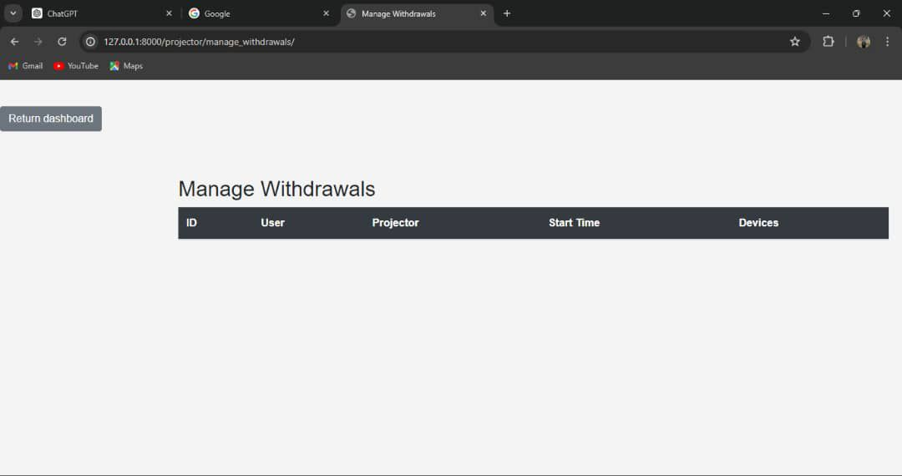

*Projector withdrawal*

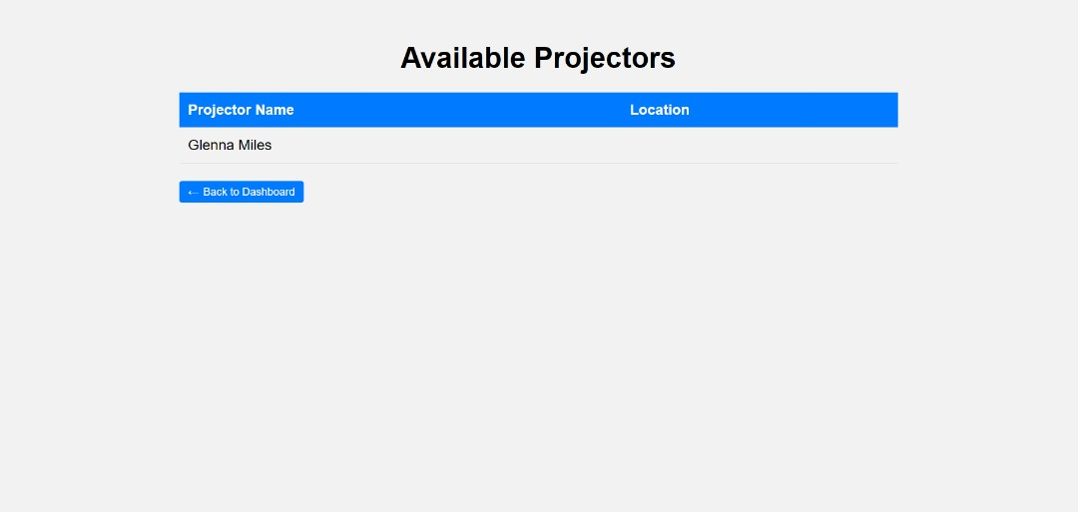

Available Projectors

* + - 1. Conclusion

This web application offers a user-friendly and efficient solution for projector management at AICS Cameroon. Implementing this system will optimize resource utilization, improve communication, and ultimately enhance the teaching and learning experience.